April 8th Budget Hearings | Zoom use for the Public

Joining a Zoom Meeting

For Computer

Click on the link below (If you are having issues clicking the link please copy the link and paste it in the address bar of a web browser, i.e. Google Chrome, Mircosoft Edge, Firefox, ect.)

https://zoom.us/j/686500616

A prompt will open and ask “Open zoom.us?”. At this time click “Open zoom.us”.

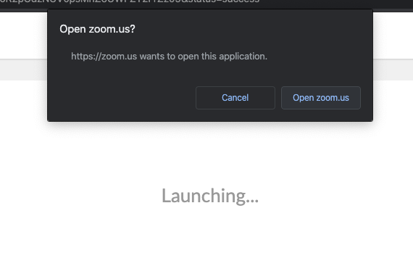

You will be asked to enter your name and email address. Please enter your information and then click “Join Webinar”

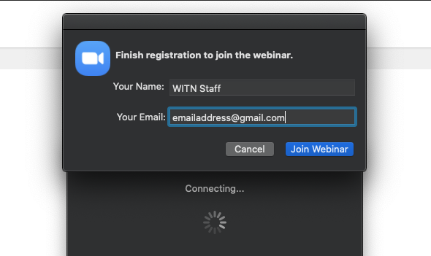

For Smartphone and Tablet

Please go to the AppStore or Google Play Store on your device. Download Zoom Cloud Meetings.

Open the Zoom App. Once you are in the app, tap the Join a Meeting button. In the Join a Meeting window please enter 686 500 616 in the “Meeting ID” box followed by entering your name in the “Your Name” box. Once everything is filled out click the “Join Meeting” button.

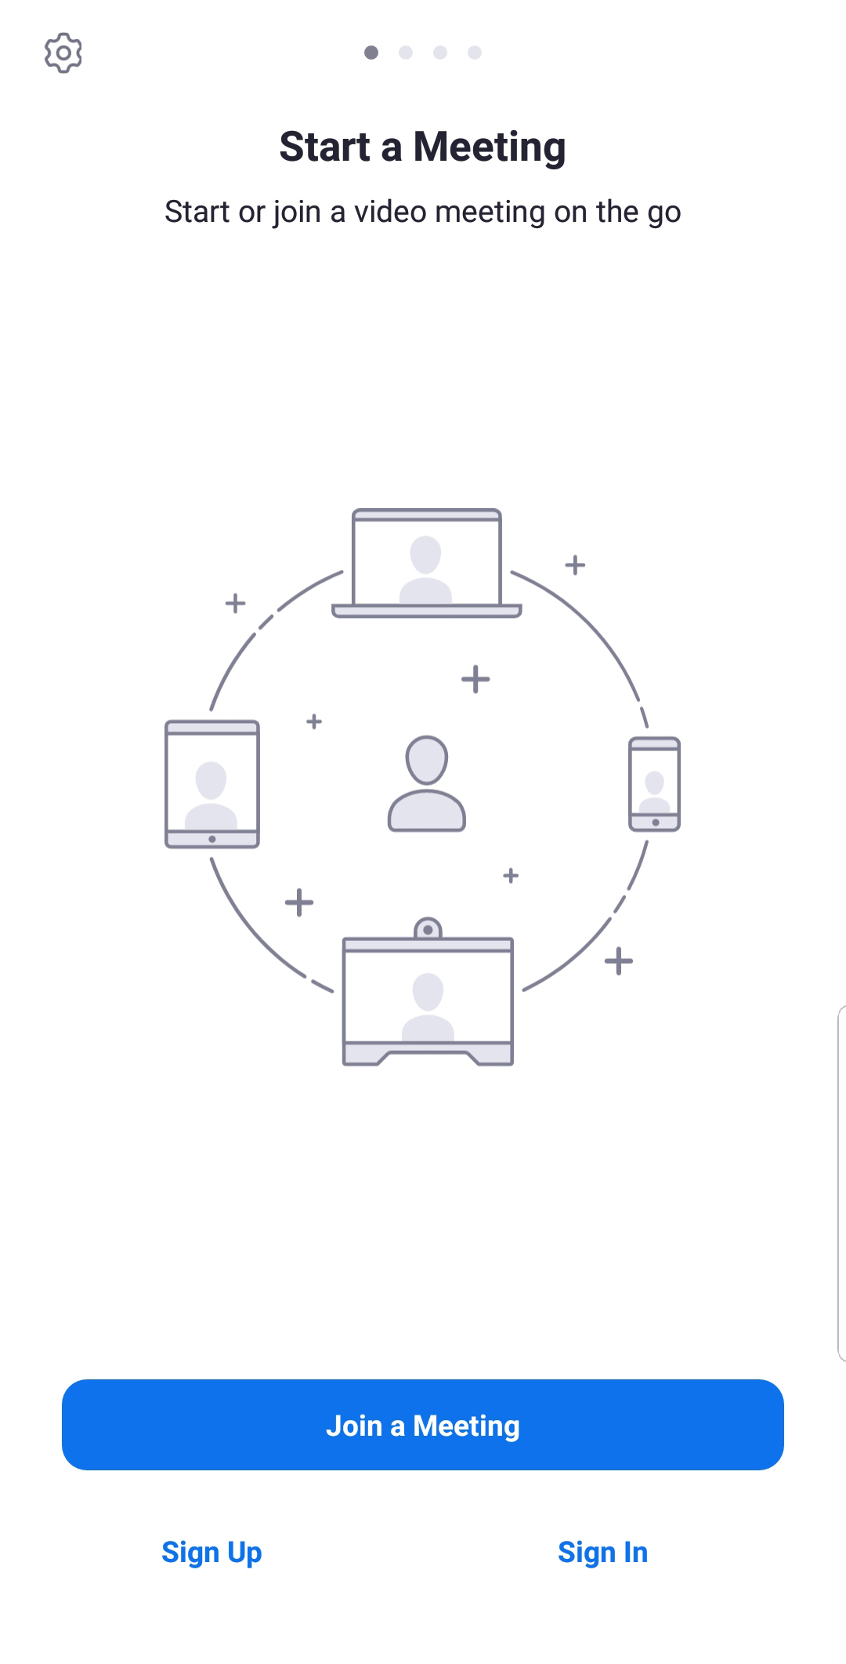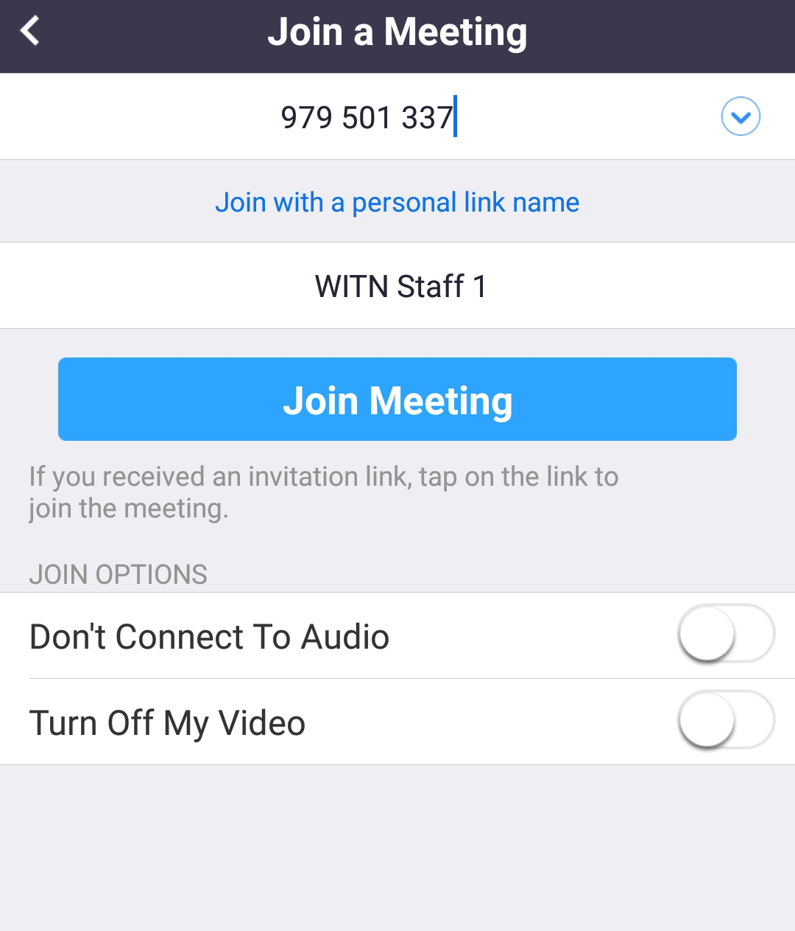

It will ask you to type in an email address. Please fill in your email address and click “OK”

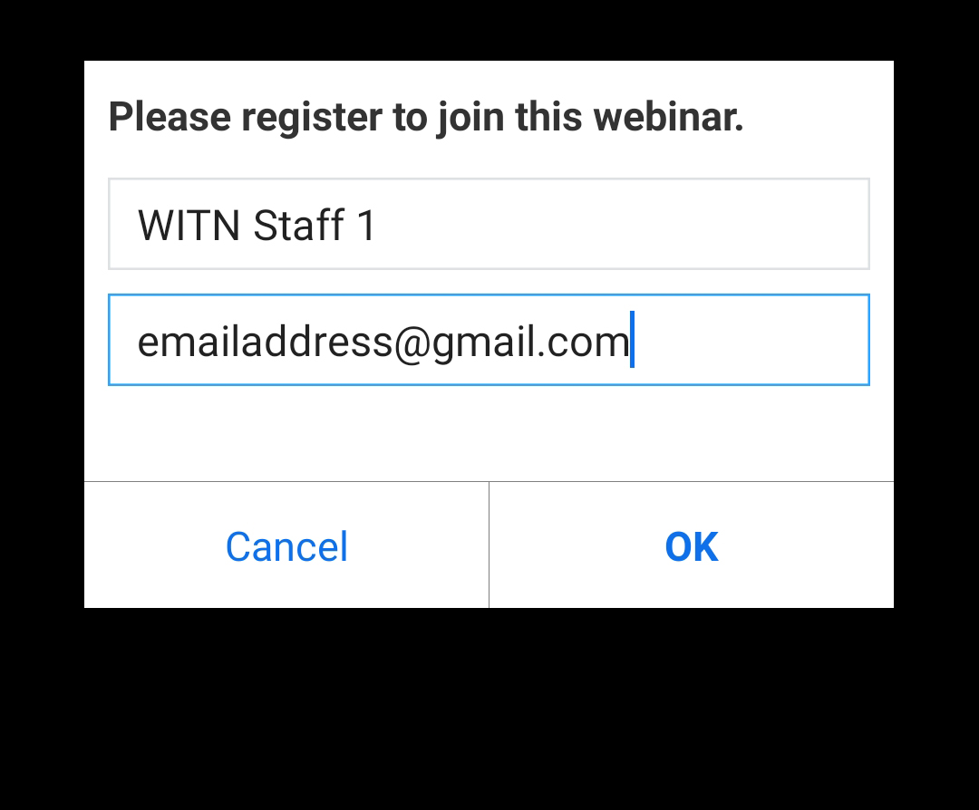

For Phone

Please dial one of the following phone numbers:

(929)-205-6099
(301)-715-8592

You will be asked for the Webinar ID. Please enter 686 500 616 and then #. You can press # again when prompted to immediately enter the meeting.

How Public Comment Works

For Computer, Smartphone, and Tablet
Once you are in the meeting, the only way you can communicate is by clicking the raise hand button (For Smartphone and Tablet Users, you might have to tap your screen to see the raise hand button). During the public comment period please click the raise hand button to be recognized for public comment.

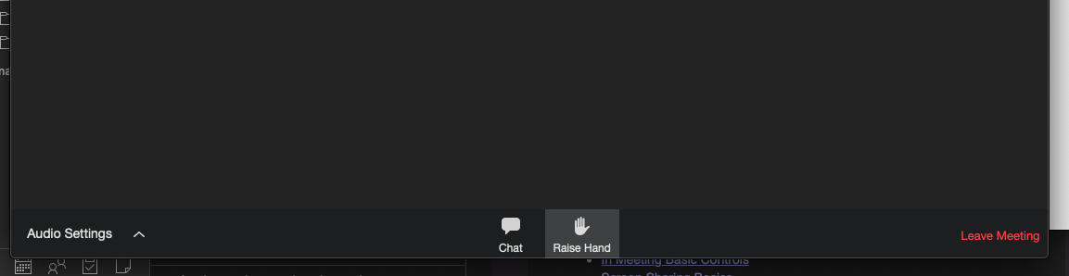

At that time the host will ask you to unmute your mic. Please click on “Unmute myself”.

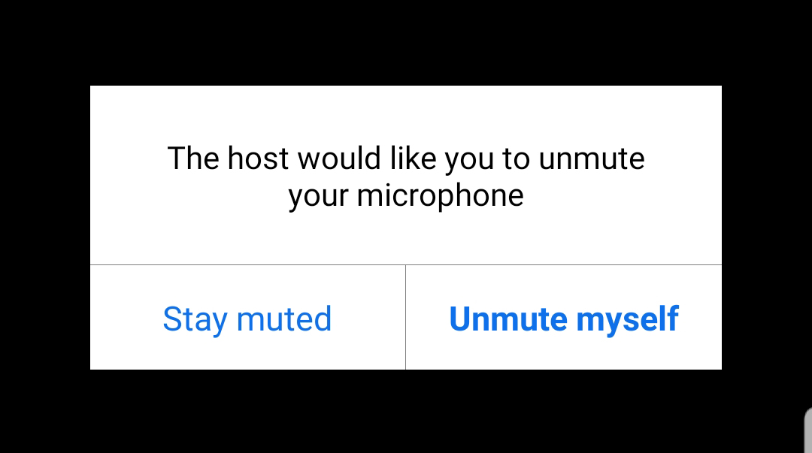

Once you are unmuted please make your comment, and when you are done you will be muted again by the host.

For Phone

Once you are in the meeting, the only way you can communicate is by pressing *9 to raise hand your hand. You will hear that you have raised your hand. During the public comment period to be recognized for public comment please press *9 to raise hand your hand. At that time the host will unmute your mic. Once you hear “You have been unmuted” please make your comment, and when you are done you will be muted again by the host.

