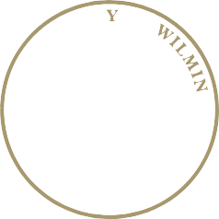
City of Wilmington

Va’Shun “Vash” Turner
City Council Member, 5th District

Louis L. Redding City/County Building
800 N. French Street Wilmington, Delaware 19801-3537

phone (302) 576-2140
fax (302) 571-4071
www.WilmingtonDE.gov

Public Works & Transportation Committee

Va’Shun “Vash” Turner, Chair
Zanthia Oliver
Loretta Walsh
Michelle Harlee
Ciro Adams, Vice-Chair
Ernest “Trippi” Congo, II
Dr. Hanifa Shabazz, Ex-Officio Member

- REVISED NOTICE

Public Works & Transportation Committee Meeting

Monday, March 19, 2018
5:00 p.m.
1st Floor Council Committee Room

Agenda

- 1. Summary Presentation on Public Works Capital Projects
- Forward Funding and Cash Financing for Public Works Capital Projects

- Presentation by Black & Veatch relating to the Proposed 6 Year Financial Plan

REV #.1 (03/12/18)

