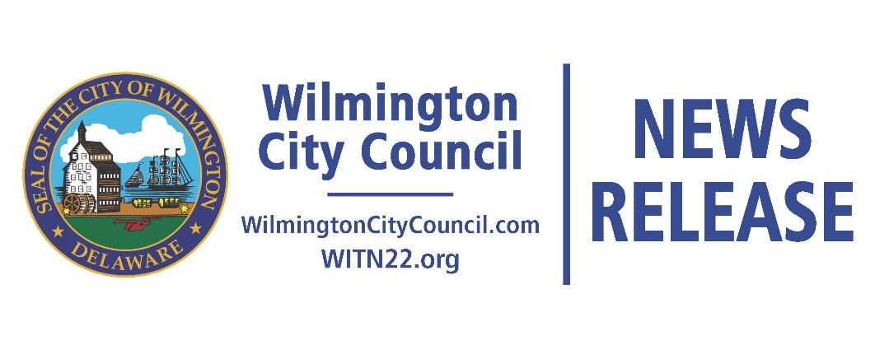

FOR IMMEDIATE RELEASE
Contact: Antoine L. Oakley
Director of Communications
302.519.4717
aloakley@wilmingtonde.gov

WILMINGTON CITY COUNCIL JOINS EFFORT
TO AID VICTIMS OF HURRICAINE HARVEY

Wilmington, DE (September 29, 2017) Wilmington City Council, the City of Chester, and PHL2TEXAS organized a three-city response to the crisis in the Texas Gulf Coast area by collecting and deploying needed resources to individuals and families in Houston impacted by hurricane Harvey. Collection centers were established in each city and donations were received on September 9th, 16th, and 23rd. In Wilmington, Reed’s Refuge, BVD Barbershop, His Image Barbershop, LNA Hair Salon and the New Castle County Sheriff’s Office served as collection sites.

“We are proud to be a part of this regional collaborative effort to provide essential supplies and support to families and communities struggling to recover in the aftermath of Harvey,” said President Shabazz. Wilmingtonians understand the importance of helping others in need and in true fashion they stepped up and generously supported this initiative.”

The drive collected thousands of donated items – for infants to seniors – including bottled water, wipes, toiletries, diapers, non-perishables, first aid kits, and clothing. On Wednesday, September 27th, all items collected in Wilmington, Chester and Philadelphia were delivered to City Hall in Chester and loaded onto a trailer. The items are scheduled to arrive in Houston on Saturday, September 30th where volunteers from each city will be on hand to unload and distribute the items to unserved areas of Houston.

Councilman Va’Shun Turner represented Council as the lead for the Wilmington relief coordination. “Our goal is to connect with residents at the grassroots-level to ensure that the donations collected through this initiative are delivered to those families and communities that have been overlooked, said Councilman Turner. Volunteers from each of the participating cities will work with Houston-based non-profits The Blacklist Association, Melanated Men of Action, National Black United Front, Houston Unity Tribe and the Tribe of Power – will distribute aid to residents in the third ward. “This was a collective effort, but, I want to acknowledge and thank Richard Raw for connecting us with these Houston non-profits.”

Wilmington City Council extends a heartfelt thank you to our Houston Relief partners: Chester Mayor Thaddeus Kirkland, Councilman William Morgan of Chester, Fred Green, PHL2TEXAS, Miracle Johnson, Richard Raw, Shawn Allen, Erin Hutt, and Vanity Sanders.

This effort is the first of a series of planned Wilmington City Council lead initiatives to provide aid and support to areas devastated by the recent hurricanes; including Puerto Rico and the U.S. Virgin Islands.
###

